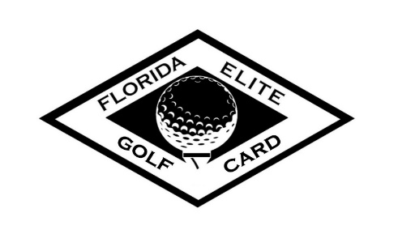
FAQ Sheet
What’s new for this year vs. last year?
- Orange County National and Celebration Golf Club have combined programs offering 3 amazing courses to play. Lunch is now included for all rounds booked before the afternoon rate price break. We’ve also gone to a loyalty rewards program, earning you a point for every dollar spent, good towards golf, merchandise, or food and beverages.
Why the name change?
- With the addition of multiple courses, we wanted to create a new identity for our card members. Giving it the new name “Florida Elite Golf Card” will allow it not to be confused with any previous discount cards we’ve had available in the past.
Who can purchase the card?
- The Florida Elite Golf Card is available to purchase for all Florida Residents with a Florida driver’s license or a Celebration Town I.D. card.
What proof of residency can I show?
- You can show your Florida driver’s license or Celebration Town I.D. card
What happens to my loyalty rewards that I earned in 2020 (Celebration Card Holders)?
- You may still redeem your punch cards that have been completed for your free golf round. If your punch card is only partially completed, 50 loyalty rewards points will be issued to your account for every round completed on your punch card.
Can my loyalty points transfer between Celebration Golf Club and Orange County National?
- Yes, they can. We do ask for advance notice to our golf shop before traveling between courses so that we may properly adjust your account with the points from the sister property.
Can I cancel my membership at any time if I choose the “pay-per-month” option?
- Choosing the monthly payment plan will lock you into the Florida Elite Card Membership for the full calendar year. At the end of the calendar year, your membership will automatically cancel unless you renew for the new year.
How do I book a round of golf online?
- Tee time reservations may be booked at either www.celebrationgolf.com or www.ocngolf.com by selecting the “FL Elite Card Holders” tab at the top and entering the password elite2021.

How do I redeem my free birthday round?
- Your complimentary birthday round may be redeemed by booking a round of golf either one week before, on, or one week after your birth date by calling the golf shop or booking through the reservation portal. You may choose the course you redeem at, but the complimentary birthday round may only be redeemed once.
What and where is the “Tooth” course?
- The Tooth Course is a 9-hole “Executive” course at Orange County National consisting of par 3’s and 4’s. Walking is included as an amenity for card holders at the rate of $5. Cart rental if you prefer to ride is an additional $10 You may book a round at the tooth course through the FL Elite Card reservation portal. Lunch or warm up range balls are NOT included with Tooth rounds.
Can I have a credit card on file to charge when I play?
- You will be able to have your valid credit card number on file in our golf shop to charge when you check in to play. It can be used on golf, merchandise, or food and beverage purchases.
How do I redeem my free video swing analysis?
- To redeem your complimentary swing analysis conducted by our Florida Elite Golf Academy, please contact Brandon Ashe at 407-566-4653 ext.4606.
Who do I contact for Florida Elite VIP travel pricing?
- For discounted prices on golf and lodging, please contact one of our Travel Executives at 407-815-3106.
How does the lunch inclusion work?
- For applicable morning rounds you will receive a voucher to redeem at the course’s dining facility for an entrée and side or a Grab and Go combo. Beverage and gratuity are not included.
What happens to my loyalty points at the end of 2021?
- If you choose to renew your FL Elite Card any unused points will roll over into 2022. If you choose to let your program expire then all unused points with expire as well.
Who do I contact for assistance with my card?
- Any of our Golf Shop Professionals will be glad to assist you with any needs you may have. You may contact us by calling 407-566-4653 ext 4608 (Celebration) or 407-656-2626 ext 2210. You may also email us at proshop@celebrationgolf.com or proshop@ocngolf.com

